Artist refugee: Mohamad Alhamod

A tailor’s son, Mohamad Alhamod grew up in Damascus among colorful fabrics and textures, and knew he wanted to follow his mother’s footsteps from a very young age. After an apprenticeship at 15, he soon opened a successful atelier in Damascus, becoming renowned throughout the Arab world for his shimmering evening gowns and innovative designs.
This all changed when war arrived at his doorstep.
His arrest at the start of the Syrian revolution in 2018 wasn’t enough to deter him, despite being held in inhumane conditions for 8 days without any explanation, but as soon as his district started being attacked, he knew it was time to leave so his children could grow up somewhere peaceful and safe.
Mohamad fled his homeland in early 2015, leaving his wife and two young daughters behind for their safety, and after two months’ arduous journey through the balkans and constant arrests, he arrived in Munich. There, he worked to take a certification to be allowed to work as a tailor in Germany, studying 3 year’s worth of material in 2 months in a language that was not his own.
His efforts were rewarded in 2018, after being reunited with his family, when he opened his first atelier in Munich, bringing a fusion of sustainable fashion with classic, elegant lines and an Arab flair German haute couture. His first collection, “Cities”, is “a statement against war” (as he explains after the runway show): inspired by the destruction he witnessed in his city, Mohamed and his employees and models (many of whom are also from refugee backgrounds) use art and fashion to process the trauma of war and rebuild a life for themselves.
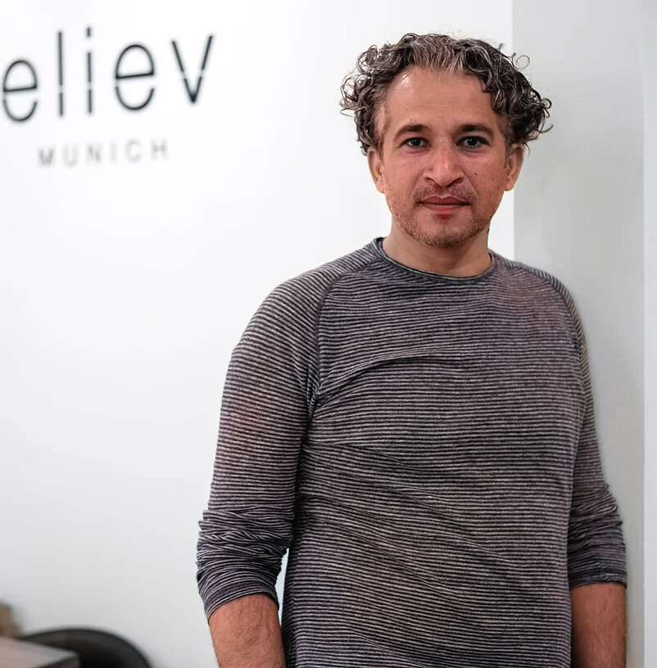
His dream is to produce future collections in Jordan, where he says there are communities of Syrian craftsmen who are without work after fleeing the war but were less fortunate than he was, whom he wants to give fair wages and further training.

